**Project Documentation**

**FITFLEX -YOUR PERSONAL FITNESS**

**COMPANION**

**Introduction**

* Project Title: FITFLEX -YOUR PERSONAL FITNESS

COMPANION

* Team ID:NM2025TMID37443

* Team Leader: VINODHINI.S

&vinodhinisankarkumar@gmail.com

* Team Members:

REENA.M &reenasusi18@gmail.com

VARSHINI.A & varshiniashok9@gmail.com

SUBASREE.T & [subasreesubasree2007@gmail.com](mailto:subasreesubasree2007@gmail.com)

**2. Project Overview**

* Purpose: Regular exercise and a balanced diet are key components of a healthy lifestyle. Fitness is not just about physical appearance; its about feeling strong, energetic, and confident. Whether you are hitting the gym, practicing yoga, or simply taking a brisk walk, every bit of movement counts towards improving your overall well-being. Find activities you enjoy and make them a part of your daily routine to boost your mood, increase your energy levels, and enhance your quality of life."

**Architecture**

* Frontend: React.js with Bootstrap and Material UI

* Backend: Node.js and Express.js managing server logic and API endpoints

* Database: MongoDB stores user data, project information, applications, and chat messages

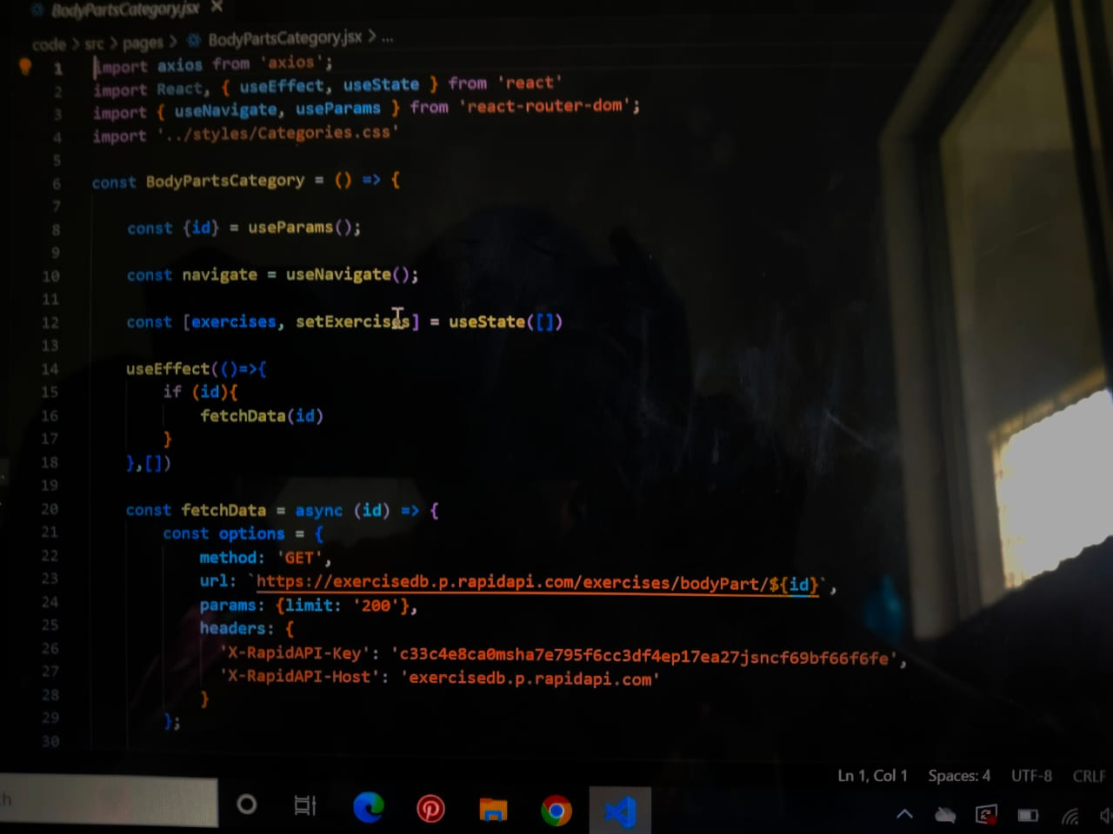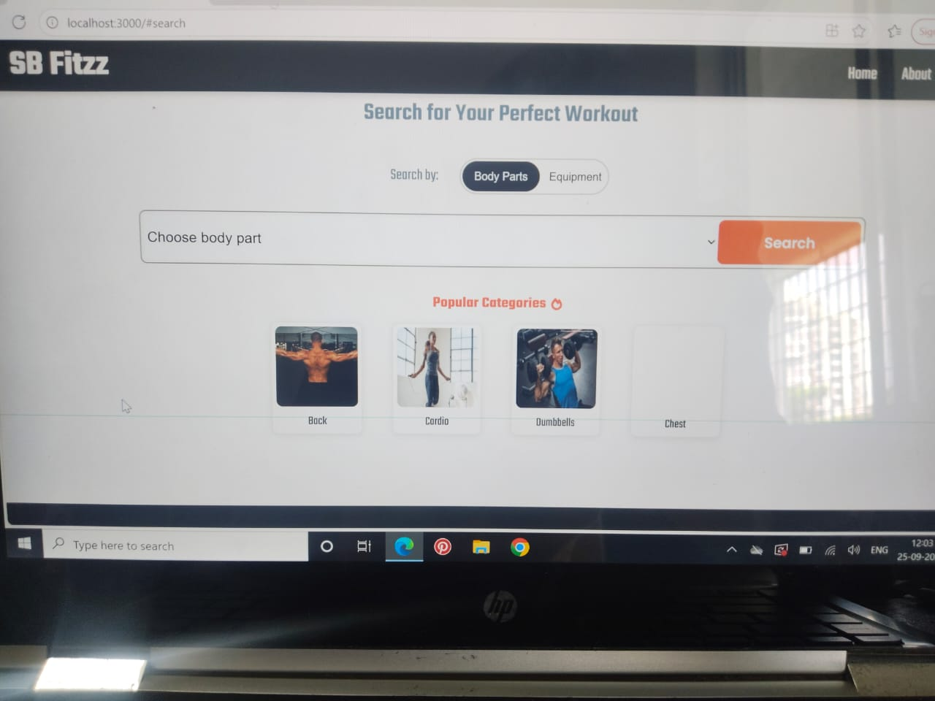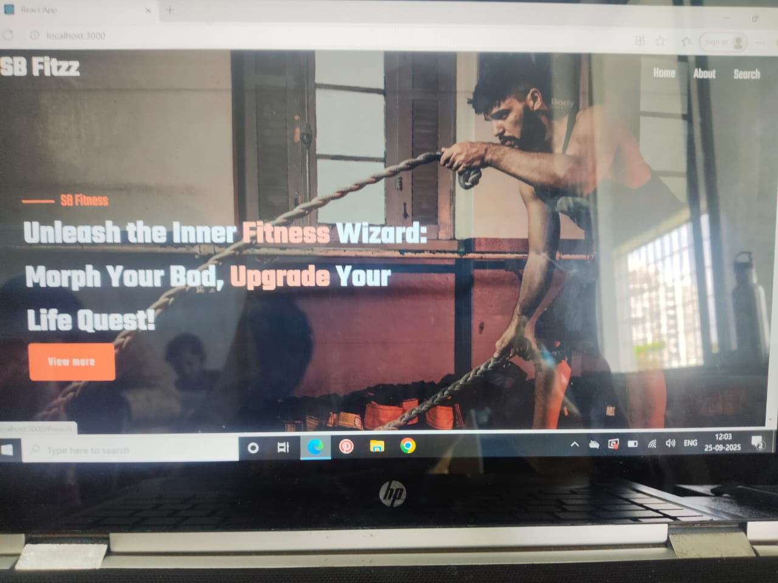

**API Documentation**

https://drive.google.com/file/d/1psp5VdHzk0FuKeTNfw5PsmNqC8T9e45v/view?usp=drive_link

**Screenshots or Demo**

https://drive.google.com/file/d/1V51roZ0v6SNum8gbhg4J3PVdp2Hk2Ndg/view?usp=drivesdk

**Known Issues**

"Known issues" (like bugs, errors, or limitations in a system/software)

Or are you asking me to list common issues in a certain area (e.g., technology, health, finance, relationships, etc.)

**Future Enhancements**

That usually comes up in contexts like project reports, product documentation, software release notes, or research papers. It’s the section where you outline possible improvements or next steps beyond what’s already delivered.